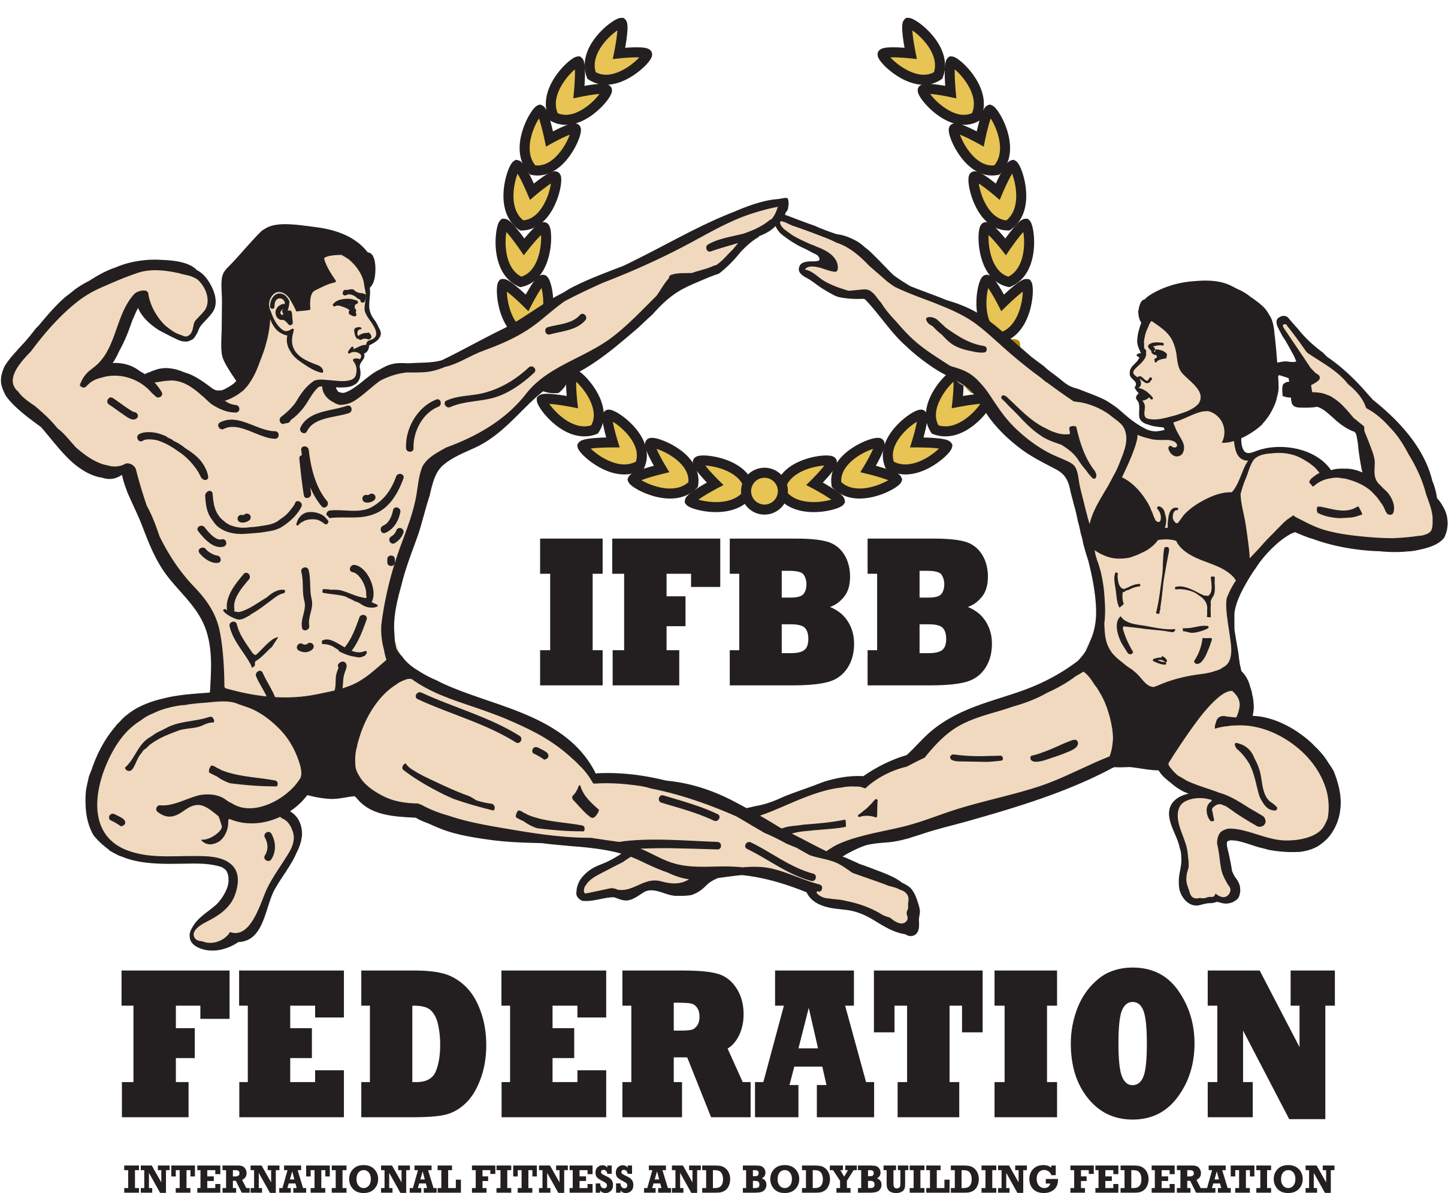 NAME OF THE EVENT
MAIN INFORMATION

NAME OF THE EVENT: Norway Classic
CITY / COUNTRY: Kristiansand, Norway
DATE: 11th of April
EVENT OPEN FOR Norway, Sweden, Denmark, Findland, Iceland, Estonia

IFBB PRO CARD QUALIFIER |  | NO ☐
IFBB INTERNATIONAL RANKING QUALIFIER |  |  |  | NO ☐
DAY OF ARRIVAL 10th of April
DAY OF DEPARTURES 12th of April

REGISTRATION DAY:  10th of april | TIME:  18.00-19.30 |  | PLACE: Caledonien Hotel, Vestre Strandgate 7, Kristiansand
WEIGHTIN DAY:  10th of april | 18.00-19.30 |  | PLACE: Caledonien Hotel, Vestre Strandgate 7, Kristiansand
*All Athletes must wear their posing attire during weigh-in for inspection. Female competitors must also bring their shoes for inspection. Posing attire and tanning must be in accordance with the IFBB rules. Any tanning which can be wiped off is not allowed.
RECOMMENDED AIRPORT: Oslo Airport Gardemoen or Kjevik Airport Kristiansand
VISA INFORMATION: PLEASE INCLUDE HERE THE VISA INFORMATION.
*An Official Letter of Invitation will be made available if required. An athlete, included in an official National Federation team, who request and receive an invitation from the IFBB Head Office or the Organizing Committee of an IFBB sanctioned EVENT for visa purposes, and uses that visa to unlawfully stay in the host country or any other country, will be subjected to the disciplinary proceedings and measures. The relevant National Federation is responsible to carefully control the proper, legal use of the visa by his/her athlete and it will be subjected to a fine and/or a suspension,
in case of any misuse and/or unlawful utilization of the same visa.
VENUE: Caledonien Hotel, Vestre Strandgate 7, Kristiansand
HOTEL INFORMATION
RECOMMENDED HOTEL:
Caledonien Hotel, Vestre Strandgate 7, Kristiansand

REGISTRATION FEE:
Each athlete must pay the IFBB registration fee of  Delegate or Extra Delegate must pay the IFBB registration fee of |  |  |  | 135€  90€
each.

Registration fee must be payed through Zubarus, link is sent to your national federation
CROSSOVERS: 65 €
DEADLINE FOR ONLINE PAYMENT: 5th of april
*Participating athletes must be recommended by their National Federation by sending the Final Entry Form with their names directly to the Organizing Committee, to the IFBB Technical Committee and IFBB Head Office in Madrid.
The final decision to allow an athlete to compete in this EVENT rests with the IFBB.
*It is also the FULL OBLIGATION AND RESPONSIBILITY of a National Federation to MONITOR ALL THE ATHLETES affiliated to this National Federation who are fulfilling a period of ineligibility due to Anti- Doping Rule Violation or any Disciplinary case, to make sure these athletes WILL NOT REGISTER/COMPETE/OR PARTICIPATE IN ANY CAPACITY in any EVENT either at National or International level, Official or Invitational.
*All posing music must be sent via mail to music@ifbbnorway.no. We will not accept USB drives. The posing music in the MP3 format must also be the only file on USB. Each competitor must affix his/her name on the USB for easy identification. The use of profane, vulgar, and offensive language is strictly prohibited in the posing music.
CATEGORIES:
- Women’s Bikinifitness  - Women’s Wellness  - Women’s bodyfitness  - Womens physique  - Artistic Fitness  - Acrobatic fitness |  |  | - Fit Pairs  - Fit Model  - Men’s Physique  - Men’s classic bodybuilding  - Men’s classic physique  - Mens Bodybuilding
AWARDS:
Top three athletes in each category will be awarded with trophies.
Top six athletes in each category will be awarded with a Certificate of Excellence and trophies. Overall winner will have a trophy.
IFBB PRO CARDS:
DISTRIBUTION
*REGISTRATION DEADLINE
PRELIMINAR ENTRY FORM: 15th of march
FINAL ENTRY FORM: 21th of march
CAMERA/VIDEO TAPE EQUIPMENT
Cameras and/or video tape equipment shall be strictly prohibited in the backstage and/or dressing room areas except when used by the IFBB authorized media person and, in any EVENT, these devices shall be strictly prohibited in the dressing room area.

GREEN CARDS
Green cards are used to limit access to the weigh-in and backstage area during the prejudging &amp, finals. They will be distributed at the judges/team managers meetings as follows:
- Five (5) or more athletes – two (2) green cards.
- Less than (5) athletes – one (1) green card.
TANNING NEEDS
The IFBB has banned all tans that can be wiped off. An official will check the tan of all athletes backstage and if the tan comes off by simply wiping, the athlete will be told to remove the tan before going on stage.
CONTACT INFORMATION:
Please send Your Entry Form to: Contact: Janne Moland  E-mail: moland@ifbbnorway.no | Please send a copy to IFBB Technical Committee:  Eng. Andrew Michalak  E-mail: amichalak5@gmail.com  Please send a copy to IFBB Head Office: Ms. Daria  E-mail: contact@ifbb.com
Contact details for additional correspondence:
Mr. Lise-Marie Sommerstad
President of the Norwegian Fitness and bodybuilding federation
E-mail: lise@ifbbnorway.no
JUDGES
Please include your nations judges on your final entry form

Scan this code to see the rules for attires of Men’s Physique and Bikini

